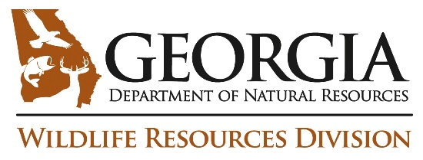
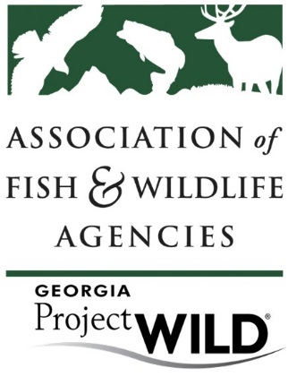

Hike Through The Guide
- List three divisions of the Project Wild activity Guide?
- Where can you find how to use Project WILD Field Investigations? How many FI are there?
- How might you create a unit plan on the topic of changing land; changing climate for middle schoolers? What might be some activities and resources?
- What is hibernacula? What page was this information on?
- Find an activity that is appropriate for lower elementary (LE) that uses description and evaluation. What is the name of the activity and what section of guide did you use to find it?
- Find an activity that is appropriate for grades 9-12 that addresses resource management. What is the name of the activity and what section of the guide did you use to find it?
- What are the objectives to Lights Out?

- What is one Extension or variation in To Zone or Not to Zone?
- What content areas are covered in the activity “Alice in Waterland”?
- What career(s) are addressed in the activity “Puddle Wonders?”
- What are the STEM connections in the activity “Water Safari?”

