Georgia centennial Farm Program APPLICATION

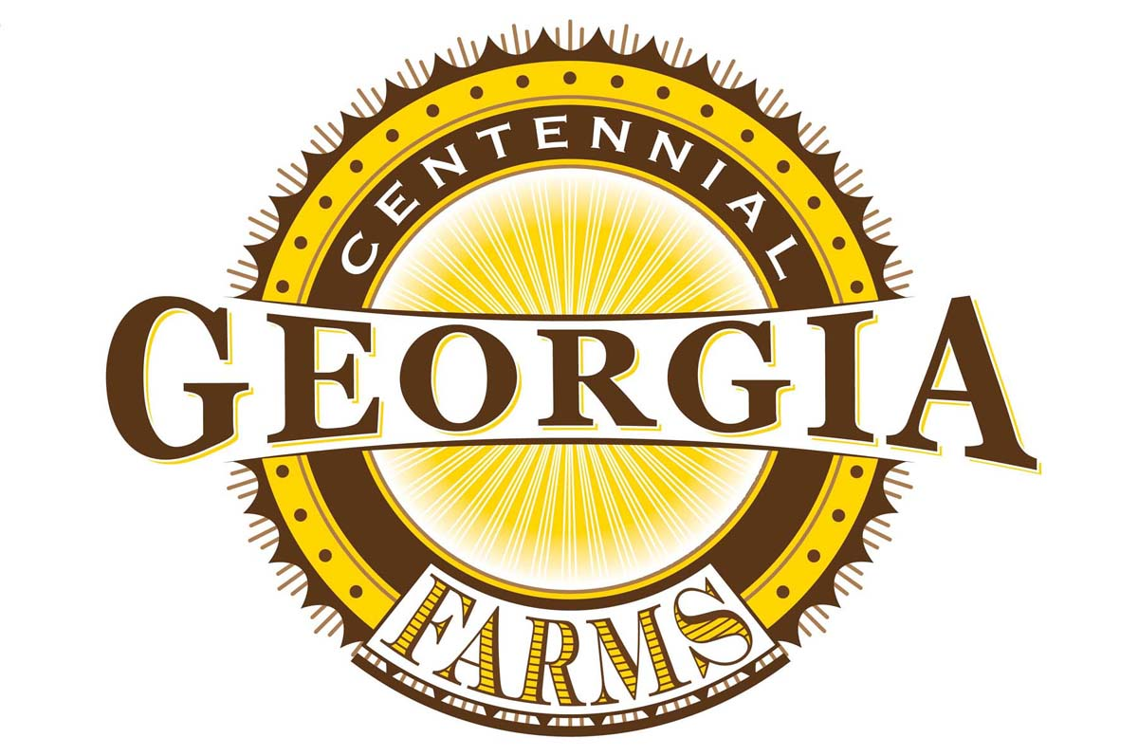

The
Georgia Centennial Farm Program is supported by a partnership among these agencies.
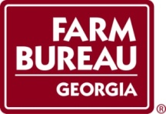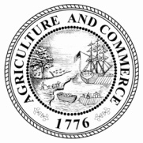
Georgia Centennial Farm Program Part 1: Instructions
Introduction
Do you currently own a working farm that has been in your family for over 100 years? Then you may have earned special recognition for your farm. The Georgia Centennial Farm Program honors Georgia’s farmers for their contributions to our state’s agricultural heritage and encourages the preservation of agricultural resources for future generations.
Awards
Participants who qualify for a Centennial Farm award are honored each year at the Georgia National Fair in October. During a special recognition program, farm owners receive a Georgia Centennial Farm Certificate of Honor signed by the Governor.
Sponsors
The Georgia Centennial Farm Program is administered by the Historic Preservation Division of the Georgia Department of Natural Resources in partnership with the Georgia Farm Bureau Federation; the Georgia Department of Agriculture; the Georgia Forestry Commission, and the Georgia National Fairgrounds and Agricenter. It is sponsored in part by Georgia EMC and the Georgia Farm Bureau Women’s Leadership Committee.
Award Selection
Applications are reviewed and selections made by the Georgia Centennial Farm Committee. Completed applications must be postmarked by June 1st of the award year in order to qualify for the current Centennial Farm awards. Applicants who qualify will be notified by mail.
Application Procedures
Please read the Award Qualifications section on the next page before completing this application. Be sure to keep a copy of your application materials. Application materials will not be returned. Application materials for qualifying farms are kept on file with the Historic Preservation Division as part of a permanent record on Georgia’s historic farms and are open to the public for research. Send the completed application and supporting documentation by May 1st to:
Georgia Centennial Farm Program
Historic Preservation Division
Georgia Department of Natural Resources
2610 Georgia Highway 155 SW
Stockbridge, GA 30281

Award Qualifications
To qualify, your farm must be a working farm with a minimum of 10 acres actively involved in agricultural production and $1,000 in annual farm-generated income. The farm must retain at least 10 acres of the original farm purchase. In addition, farms must meet the requirements for one of the following award categories:

Centennial Heritage Farm Award
- Owned continuously by members of the same family for 100 years or more
- Listed in the National Register of Historic Places

Centennial Farm Award
- Does not require continual family ownership
- Farms must be at least 100 years old
- Listed in the National Register of Historic Places

Centennial Family Farm Award
- Owned continuously by members of the same family for 100 years or more
- Not listed in the National Register of Historic Places

*The line of ownership may be traced down through either side of the family including descendants such as brothers, sisters, nephews, or nieces.

*For information on the National Register of Historic Places, contact the Historic Preservation Division at (770) 389-7842 or visit www.georgiashpo.org.

*Farm land used for tree farming can qualify as a working farm only if the farm operates from a forest management plan written by a registered forester, has at least 10 acres of forest land, and will have forest products harvested at some scheduled time in the future.

*Once a farm has received a Centennial Farm award it will not qualify for another Centennial Farm award category. Exceptions are made for Centennial Family Farms that are listed in the National Register of Historic Places at a later date. These farms may reapply for the Centennial Heritage Farm Award category.
*Only one certificate will be issued for each family farm unless the original farm has been subdivided for more than 100 years and the subdivided farm parcels have also achieved 100 years of significance as separate family farms.

Georgia Centennial Farm Program Part 2: Application Form
Award Category
Check one of the following categories and complete those sections indicated.

My farm meets the requirements for the:
- Centennial Heritage Farm Award (complete sections 1, 2, 3, 4, and 5)
- Centennial Farm Award (complete sections 1, 3, 4, and 5)
- Centennial Family Farm Award (complete sections 1, 2, 3 and 5)

Section 1. Current Ownership Information

Farm name to appear on award certificate ___________________________________________

Address of farm ________________________________________________________________

City ___________________ County ______________________ Zip ____________________

Name of farm owner ____________________________________________________________

Mailing address of owner ________________________________________________________

City ____________________ County ________________ State ______ Zip _______________

Daytime telephone number ____________________ Email address _______________________

Application prepared by ___________________ Relationship to owner ____________________

Number of acres in farm at present _________________________________________________

Number of acres in agricultural production ___________________________________________

What are the farm’s major crops or products? _________________________________________

Value of current agricultural production:
___Less than $1,000 ___$1,000 - $10,000 ___$10,000 - $50,000

GA State Senate Rep. __________________ GA State House Rep. ____________________

U.S. House Rep. _____________________

How did you hear about the Georgia Centennial Farm Program? _________________________

Section 2. Farm History

Year of acquisition by member of your family ___________________________

Number of acres in original purchase __________________________________

Number of acres of original purchase still retained ________________________

History of the Farm

On a separate sheet, briefly describe the history of the farm. Remember that the answers to these questions will provide your family with a written record of your family history. Consider the following questions to provide a farm history.
- How did your family initially acquire the farm?
- What crops/livestock were produced?
- When were the house and outbuildings constructed?
- Are all of the original buildings remaining? If not, what happened to them?
- Relevant family stories.

List Family Owners

List all family members who have owned the farm. Begin with original owners and continue to the present owner; indicate relationship to present owner and give dates when the property was owned. Continue on a separate sheet if additional space is needed. Attach copies of all deeds to the application.

NAME | RELATIONSHIP TO PRESENT OWNER | DATES PROPERTY WAS OWNED | DEED BOOK  NUMBER AND PAGE | BIRTH AND DEATH DATES
EXAMPLE:  John Smith | Great Grandfather | 1860-1886 | Deed Book C, page 113 | Jan. 1, 1830-  Sept. 15, 1886

Section 3. Supporting Documentation

The following items MUST be included with your application:

- A formal boundary map of the farm.

- A general map showing the location of the farm in relation to the nearest town. The map must be legible and measure at least 8-1/2 inches by 11 inches in size. The map must include the names of surrounding roads and/or state highways and a compass rose.

- A sketch map illustrating the general layout of the farm. Indicate where farm buildings, outbuildings, and fields are located or where they were located, but are no longer standing and show the original acreage.

- Current photographs showing crops, fields, pastures, cattle, farm buildings, etc. Please submit digital photos in hard copy and on a disc.

- Copies of historic photographs of the farm and historic owners (optional, but preferred if available). Please submit in hard copy and on a disc.
- Photocopies of supporting documents, such as deeds, to verify at least 100 years of continual family ownership. Please highlight appropriate dates, legal land descriptions, and ownership on each document. Do not include binders, notebooks, or covers of any kind.

Section 4. National Register of Historic Places (if applicable)

Name of National Register listing: ________________________________________________

Describe any major additions or alterations to the property since its listing in the National Register: _____________________________________________________________________

Section 5. Future Communication
Please let us know if you would like to remain on our mailing list

- Yes, I would like to continue to receive mailings about the Georgia Centennial Farm program
- Mail
- Email
- No, I would not like to receive future mailings about the Georgia Centennial Farm program

Section 6. Statement of Farm Owner

The statements made in this application are accurate and correct to the best of my knowledge.

__________________________________ ________________________
Signature Date of Application

Please send completed application form (pages 3-7) and additional materials to:

Georgia Centennial Farm Program
Historic Preservation Division
Georgia Department of Natural Resources
2610 Georgia Highway 155 SW
Stockbridge, GA 30281

Questions: 770-389-7844

Release for the Georgia Centennial Farm Program

"I, _________________________________, hereby grant to the Georgia Department of Natural Resources the right to use and make any and all photographs or videotape recordings of me as a result of my application to participate in the Georgia Centennial Farm Program. I hereby renounce any claim to any payment for or royalty from these photographs or videotape recordings. With regard to any narratives, photographs, and videos that I am providing with my application, I warrant and represent that I own all right, title and interest in and to the narratives, photographs and videos or otherwise have the right to license them to the Georgia Department of Natural Resources without infringing or violating any law or right of any third party. I hereby grant the Georgia Department of Natural Resources a worldwide, non-exclusive, and royalty-free license in perpetuity to use, reproduce, exhibit, transmit and distribute, including but not limited to any and all markets and media and advertising, the narratives, photographs, and videos for promoting the Georgia Centennial Farm Program and for any other lawful purpose of the Georgia Department of Natural Resources. I hereby waive, release, indemnify and hold harmless the State of Georgia, the Georgia Department of Natural Resources, and the Department’s Board members, officers, employees and agents from and forever promise not to sue them on any and all claims, demands, rights, causes of action, liabilities, losses, damages, costs and expenses (including reasonable attorneys’ fees), whether known or unknown, arising out of or in any way relating to the Department’s use of the narratives, photographs and videos for any lawful purpose."

Name of Farm: ____________________________________

